Mobile Application Development
Difference between let var and Const
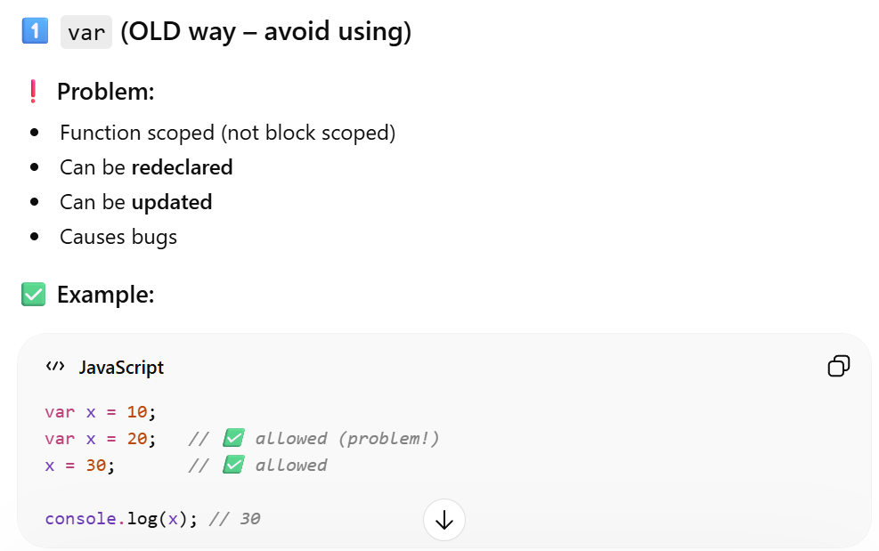
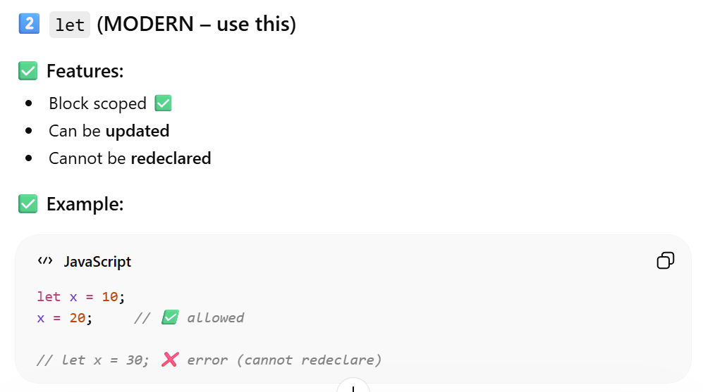
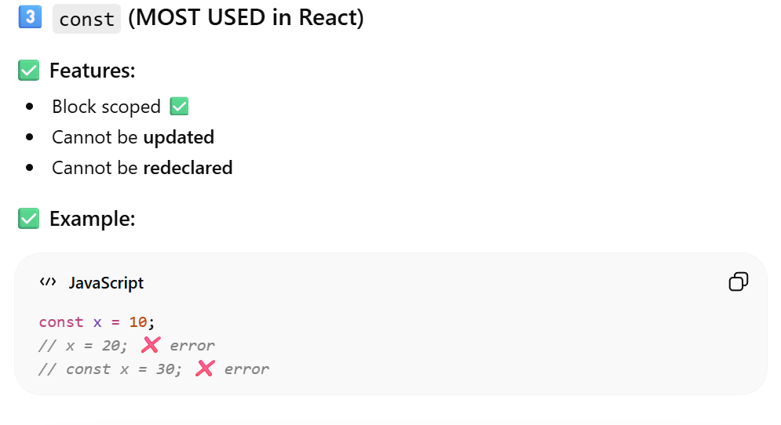
What is React Native?
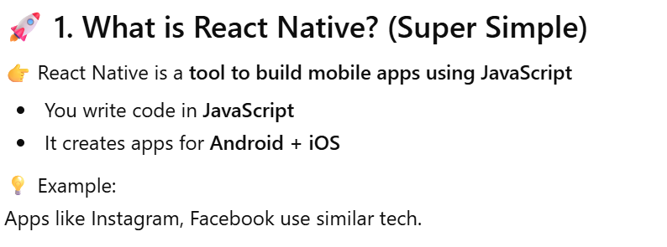
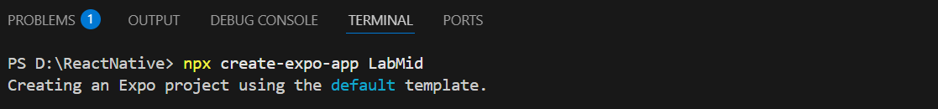
How to create blank project using expo cli

‘Hello World’ Program in React Native
Text Components
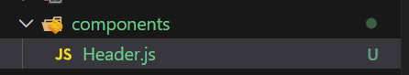
Header.js
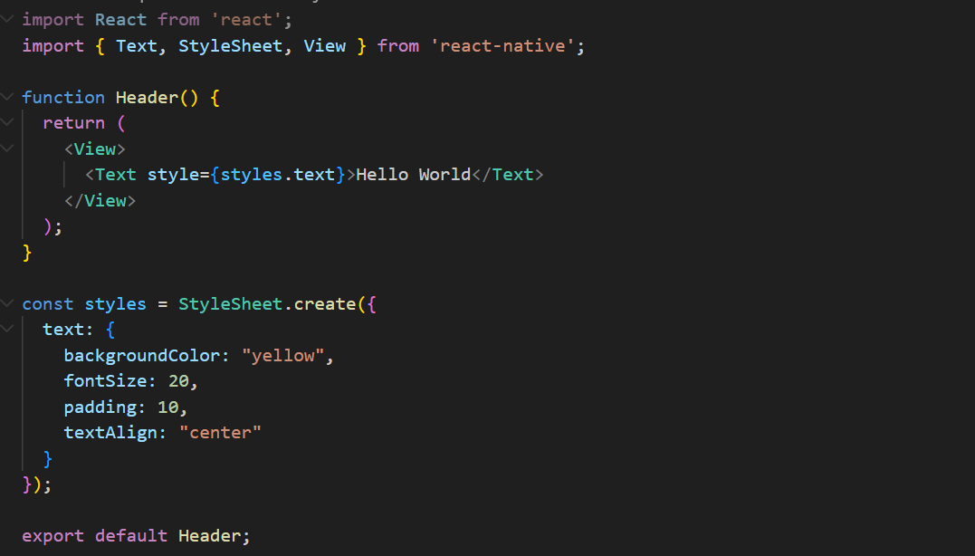
App.js
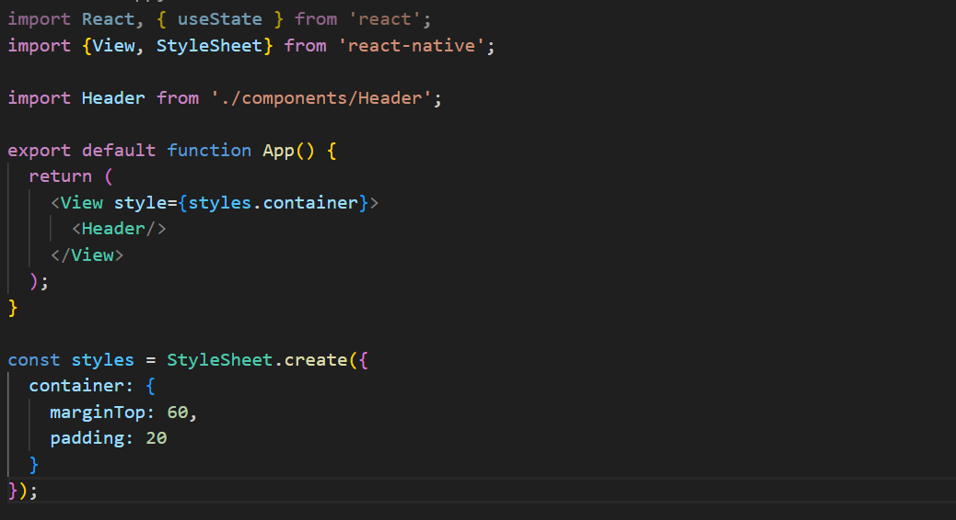
Output
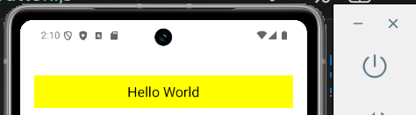
Text Input Component
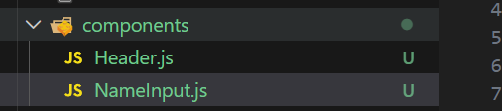
NameInput.js
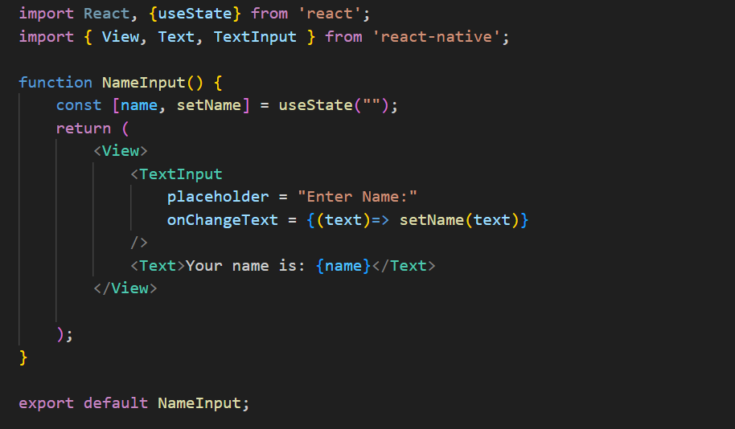

App.js
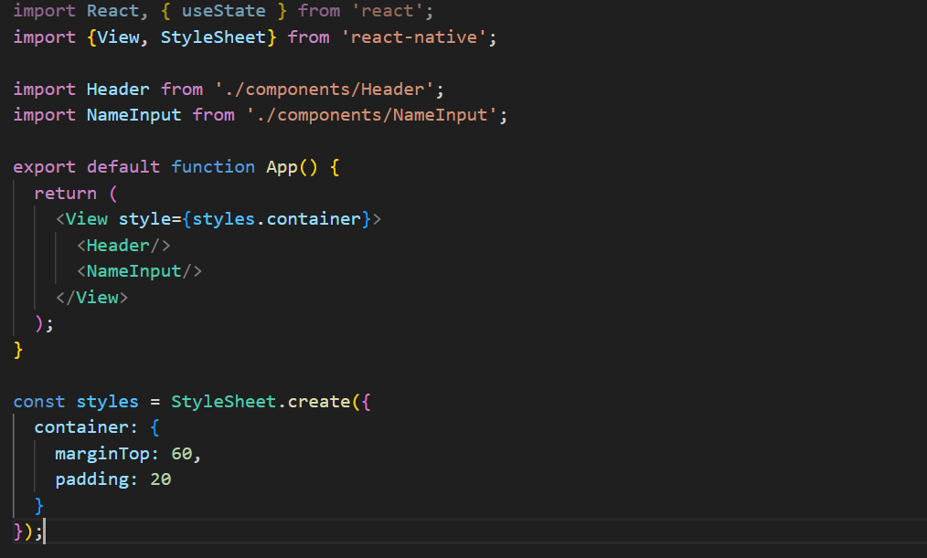
Output
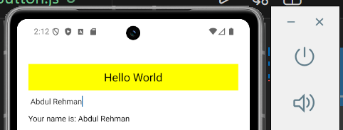
Button Component
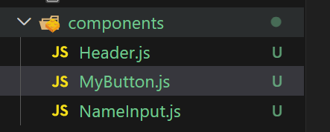

MyButton.js
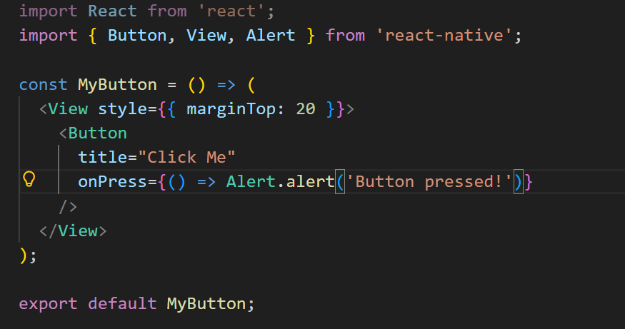
App.js
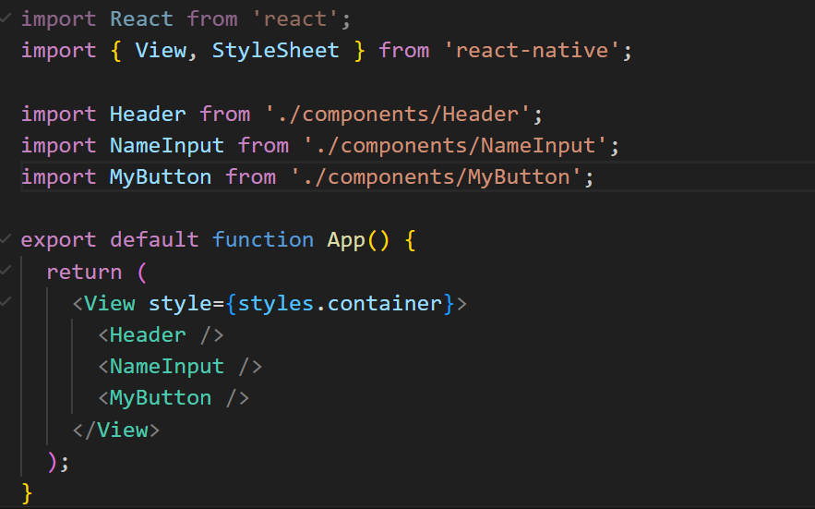
Output
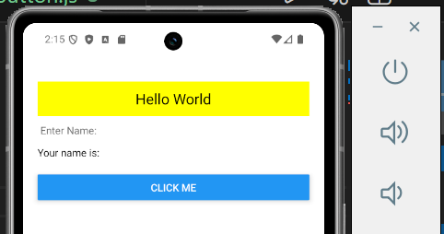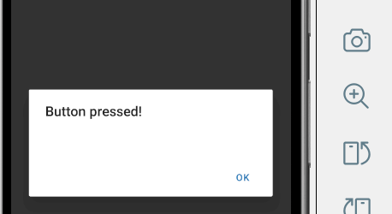
Limitations of button
1. Very limited styling: Very limited styling options (no padding, margin, border-radius control)
2. Not flexible in design: Only color property can be changed (mostly Android)
3. Platform differences: Android and iOS buttons look different. You cannot fully control consistency across devices
4. No support for icons: Cannot add icons inside the button
5. No loading state: No built-in loading state (spinner or “loading…” text not supported)
6. No advanced interaction effects: No control over animations or press effects. Not suitable for modern or professional UI designs
App to find sum of two numbers
Sum.js
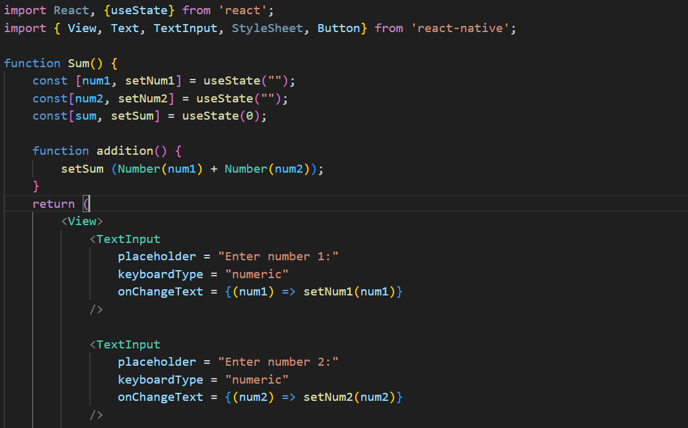
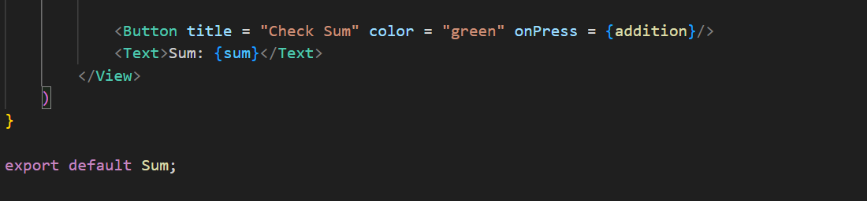
App.js
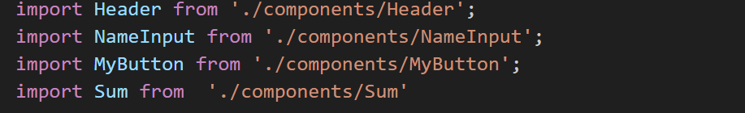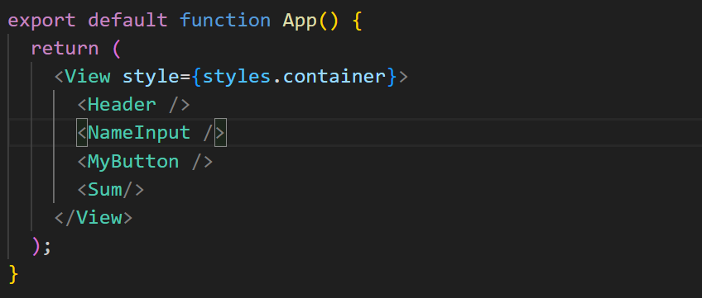
Output
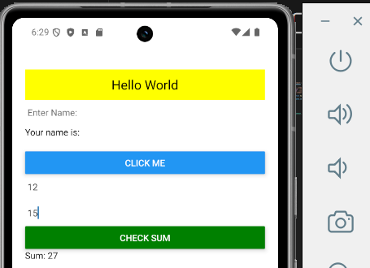
Touchable Components
Touchable components are special parts in React Native that let you click or tap on things.
They make text, buttons, or images work like buttons.
Why we use them?
We use touchable components because:
- To detect taps (clicks)
- To make buttons
- To make app interactive (user can use it)
- To show effect when you press something
Why we use Touchable components instead of Button?
In React Native, we use Touchable components because they are more flexible than the default Button.
Touchable components
- Fully customizable
- You can put Text, Images, Icons, Views
- You can design your own button
- You can control press effects
1. Touchable Opacity
TouchableOpacity is a touchable component in React Native that makes a view slightly transparent (fade) when you press it.
Why we use it?
- We use TouchableOpacity to:
- Detect taps (clicks)
- Give a nice visual effect (fade)
- Create custom buttons
Folder Structure
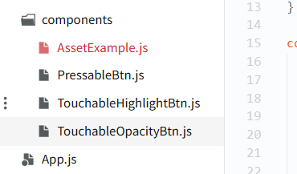
Code
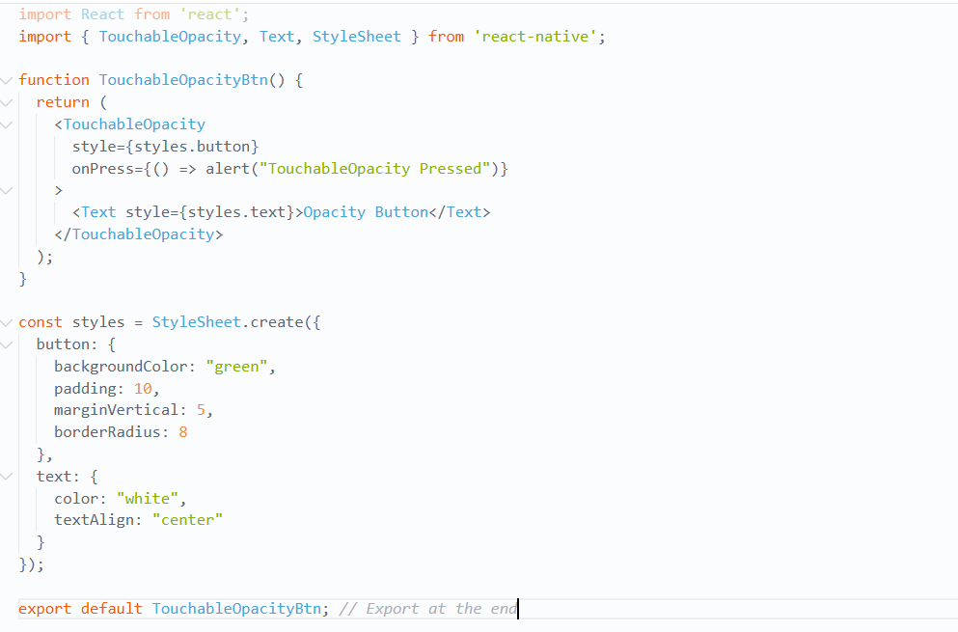
Output
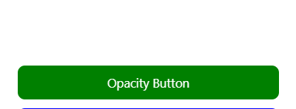
2. Touchable Highlight
TouchableHighlight is a React Native component that makes something change color when you press it.
Why we use it?
We use TouchableHighlight to:
- Detect taps
- Show color effect on press
- Make buttons more interactive
Code
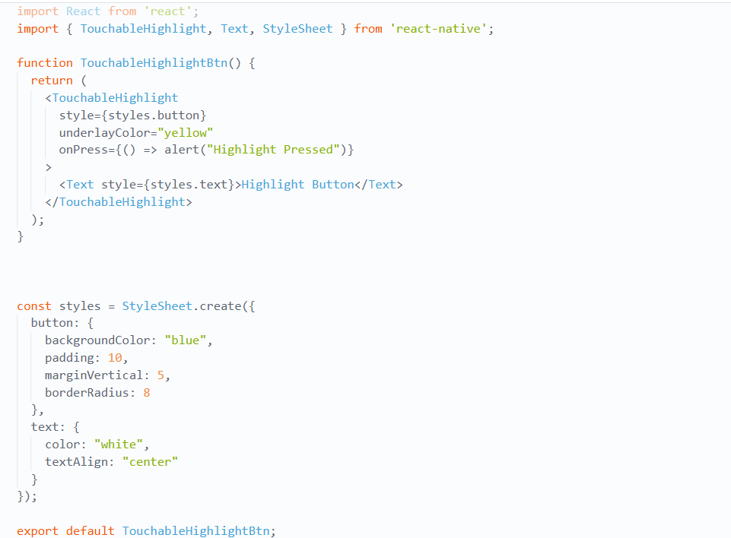

Output
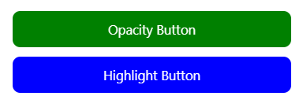
3. Pressable
Pressable is a React Native component that can detect when you touch, press, or release something.
What it does:
It can detect:
- when you press
- when you release
- when you long press
Code
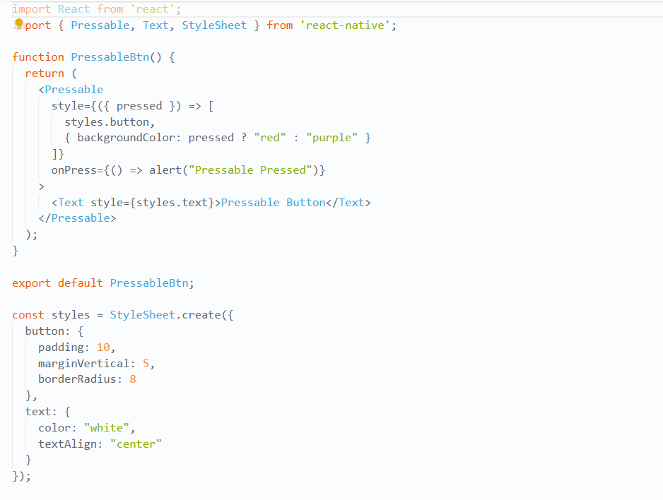
Output
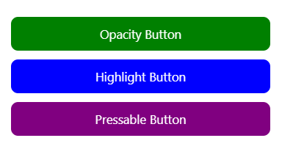
App.js
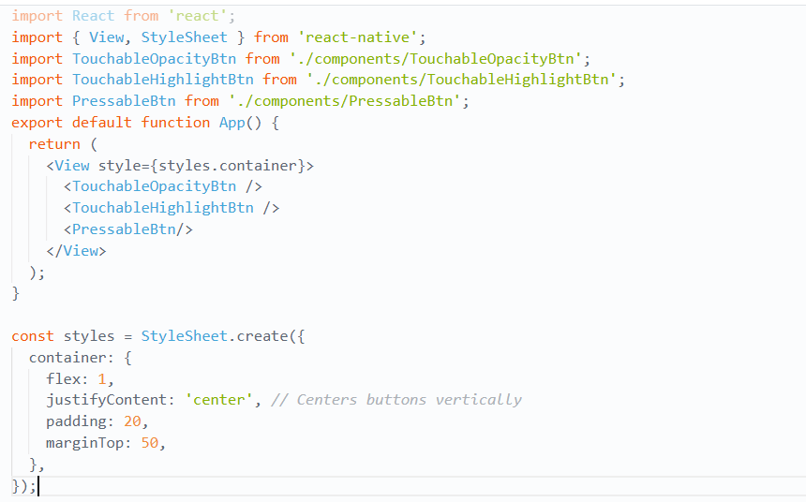
What is ScrollView?
ScrollView is a component in React Native that lets users scroll up and down (or sideways) to see content.
It is used when your content is bigger than the screen.
How ScrollView Works
- It wraps all your content inside a scrollable area
- It connects with the touch system, so users can scroll using their fingers
Important Rule
Keep in mind that ScrollViews must have a bounded height in order to work, since they contain unbounded-height children into a bounded container (via a scroll interaction).
How to fix it:
How to fix it:
- Use flex: 1 in parent views
- Or give height manually (not recommended)
If you forget this:
- Scroll may not work
- Layout errors can happen
Limitation
Sometimes ScrollView cannot control touch completely
What actually happens?
- You are trying to scroll (swipe up/down)
- But inside ScrollView, there is another component (like a button)
- That component may capture the touch first
So:
- Scroll stops or doesn’t work smoothly
- Button or touchable handles the touch instead
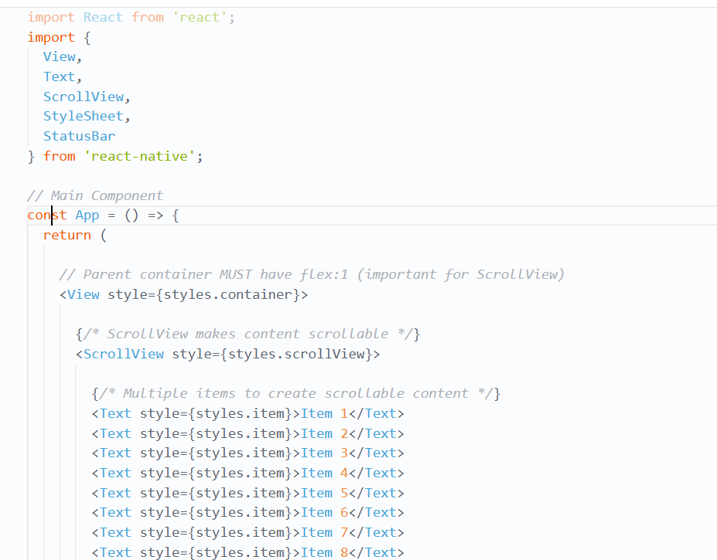
Code

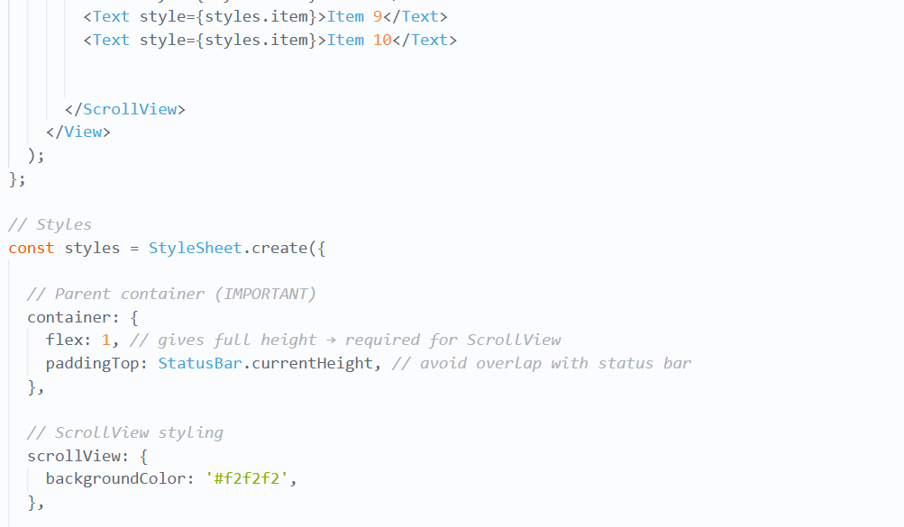

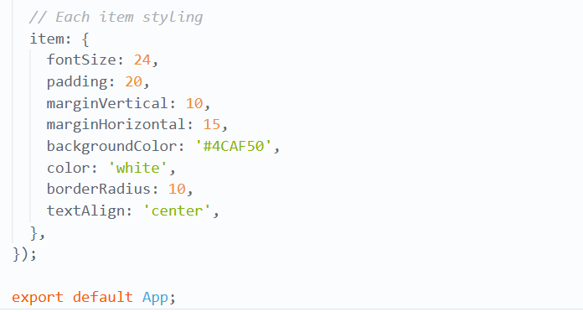

Output
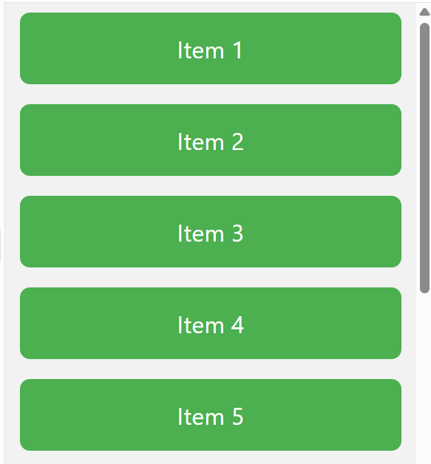

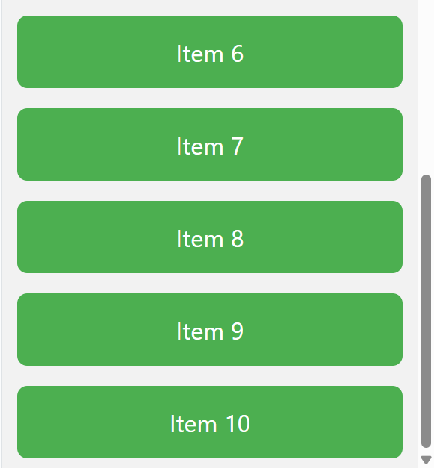

What is FlatList in React Native?
FlatList is a component in React Native that is used to display a large list of data efficiently by rendering only the items that are currently visible on the screen and loading more items as the user scrolls.
Why we use FlatList?
- Saves memory usage
- Improves performance
- Handles large lists efficiently
Three Important Props of FlatList
1. data
This is the array of items you want to display in the list.
2. renderItem
- This defines how each item in the list should be displayed.
- It is a function that takes an item and returns a component.
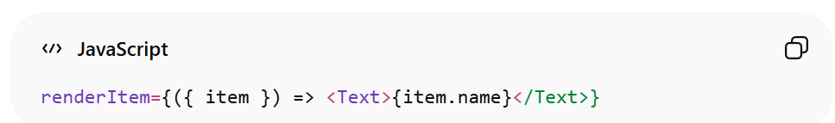
3. Key Extractor
- This tells FlatList how to uniquely identify each item.
- It helps React efficiently update list items.
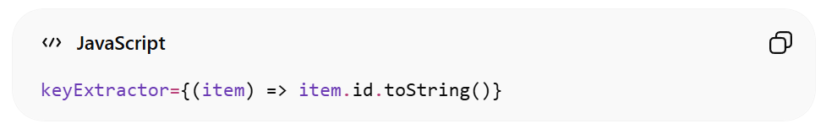

Code
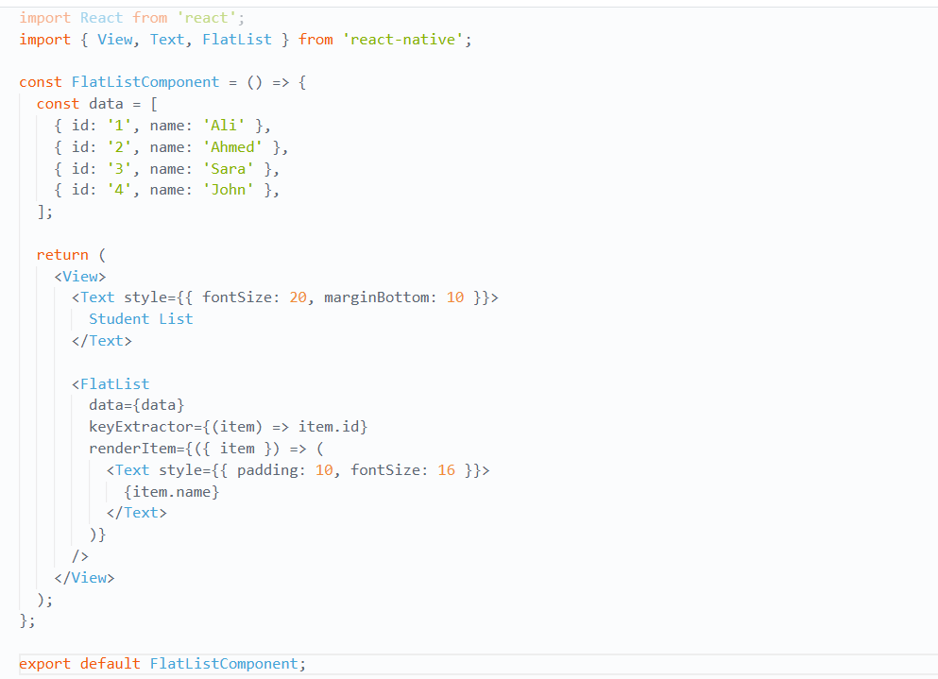
App.js
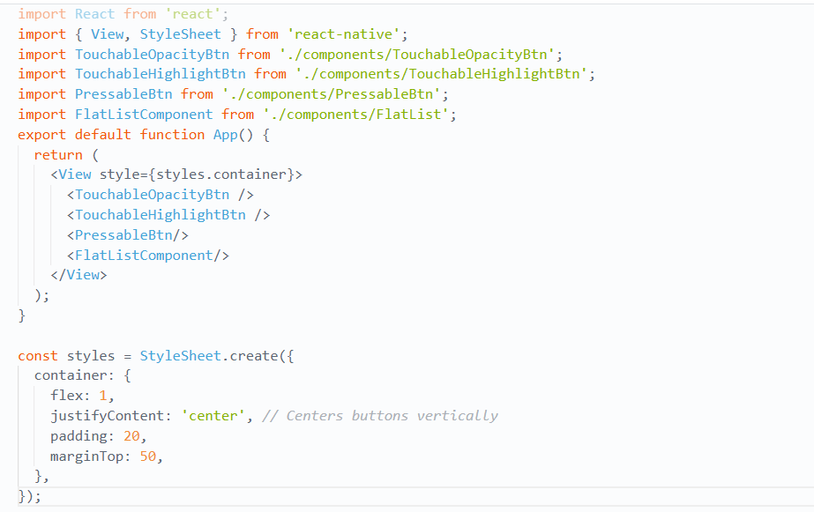
Output
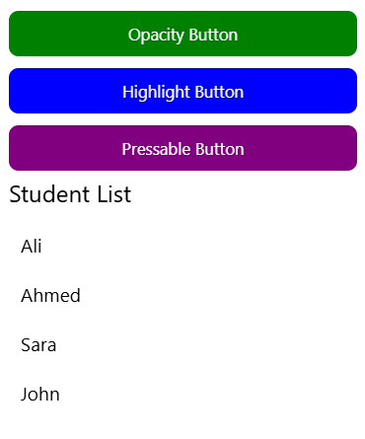
Flat List vs Scroll View
ScrollView Rendering
- ScrollView renders all its child components at once
- It loads everything immediately on the screen
- Even items that are not visible yet are also created
Problem
- Causes slow performance
- Uses more memory
- Not good for very long lists

Example Situation
Imagine:
You have a list that takes several screens to scroll
ScrollView still creates:
- All JS components
- All native views
- Even if user cannot see them yet
This wastes resources and slows the app
FlatList Solution
- FlatList solves this problem
- It renders items only when needed (lazy loading)
- It shows items when they are about to appear on screen
- It removes items that go far off screen
Benefits of FlatList
- Saves memory usage
- Improves performance
- Handles large lists efficiently
Extra Features of FlatList
FlatList also supports advanced features:
- Item separators (lines between items)
- Multiple columns layout
- Infinite scrolling (load more data while scrolling)
- Built-in optimization features

React Navigation
Why Do We Need Navigation?
In a web browser:
- Clicking a link → opens a new page
- Pressing back → goes to previous page
This works because the browser has a history system
But in React Native:
- No built-in history system
- React Native itself doesn’t include built-in navigation, so we usually use libraries like React Navigation
What React Navigation Does
React Navigation:
Keeps track of screens in a stack (history)
Let’s you move between screens
Adds mobile features like:
- Header (top bar)
- Animations
- Swipe gestures
Just like real mobile apps
Think of it like:
- Opening a new page → going from Home → Profile
- Going back → Profile → Home

Types of Navigation in React Native
1. Stack Navigation (Native Stack Navigator)
- Works like a stack (LIFO)
- New screen goes on top
- Back button removes the top screen
Example:
Home → Details → Profile → Back → Details
2. Tab Navigation
- Shows tabs at top or bottom
- Each tab is a different screen
Example:
- Home | Search | Profile
Best for:
- Apps like Instagram or WhatsApp
3. Drawer Navigation
Side menu (opens from left or right)
Example:
☰ Menu → Home / Settings / Profile
Best for:
- Apps with many sections

Installing the native stack navigator library
Each navigator in React Navigation lives in its own library.
To use the native stack navigator
we need to install @react-navigation/native-stack:
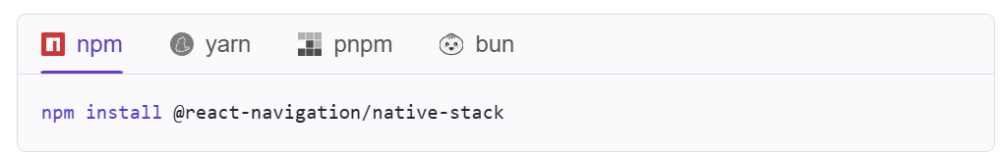
Installing the elements library
The @react-navigation/elements library provides components designed to work with React Navigation. In this guide, we'll use components like Button from the element’s library:
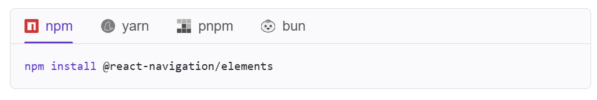
Creating a native stack navigator
We can create a native stack navigator by using the createNativeStackNavigator function:
STEP 1: Basic Setup (1 screen only)
Code
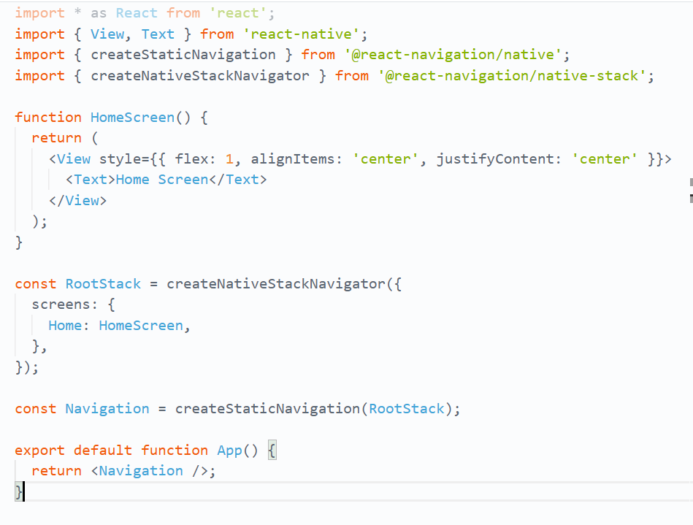
Output
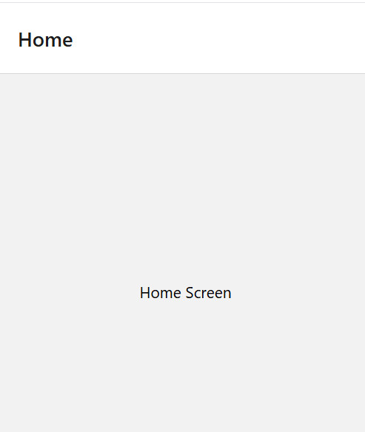
What happens?
- Only Home screen exists
- It opens first
- No navigation yet
STEP 2: Add second screen
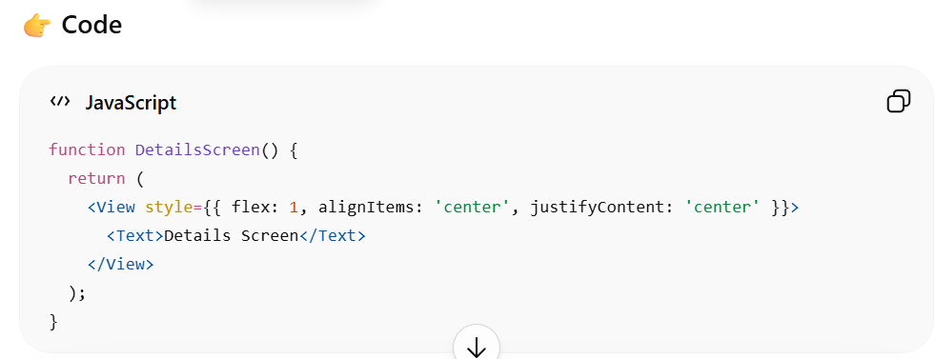
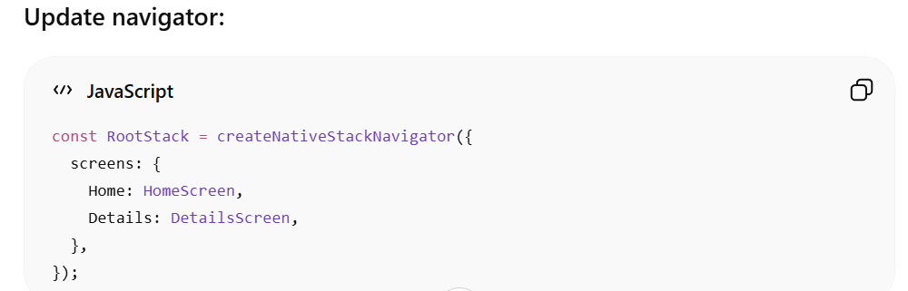
What changed?
Now app has:
- Home screen
- Details screen
But Home still opens first by default.

STEP 3: Set initial screen
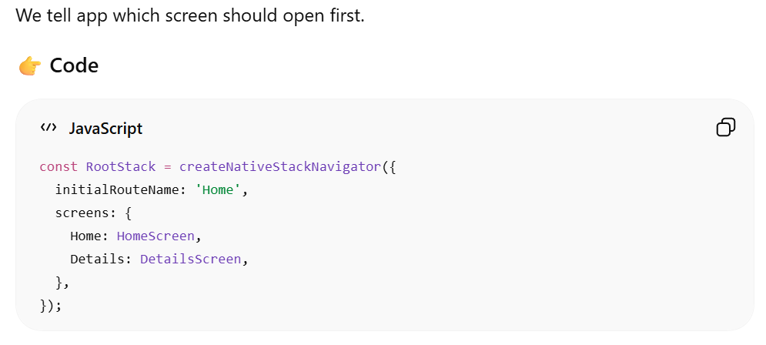Meaning:
- App starts on Home screen
- If you change to 'Details', app opens Details first
STEP 4: Add screen options (inside screen)
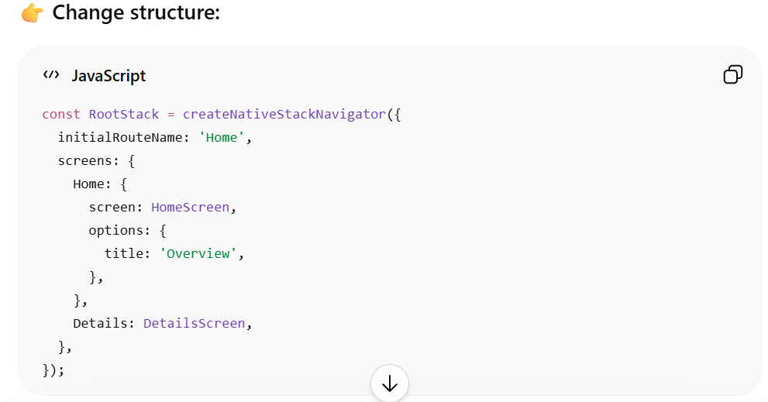

Meaning:
- Home screen header title becomes “Overview”
- Instead of default “Home”
STEP 5: Add global screen styling (screenOptions)
Now we apply settings to ALL screens.
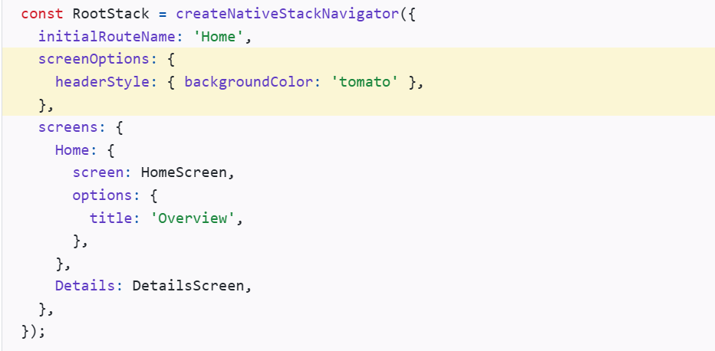
Final Code
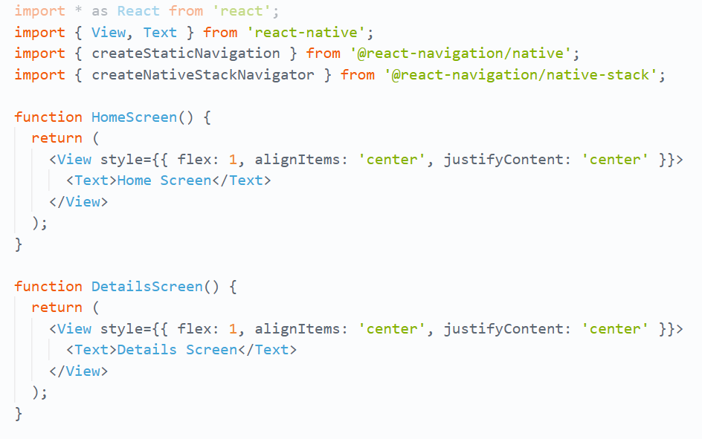
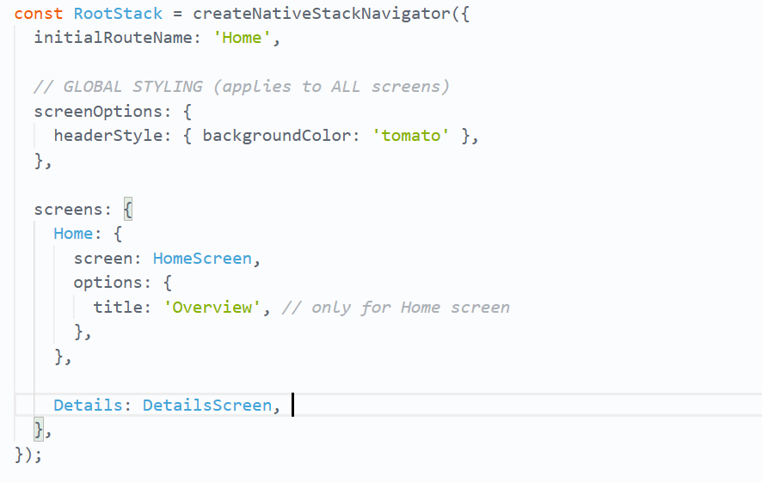
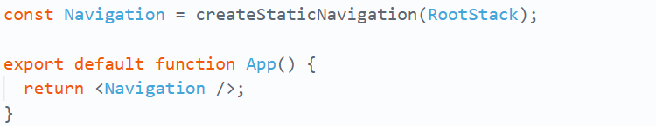
Output
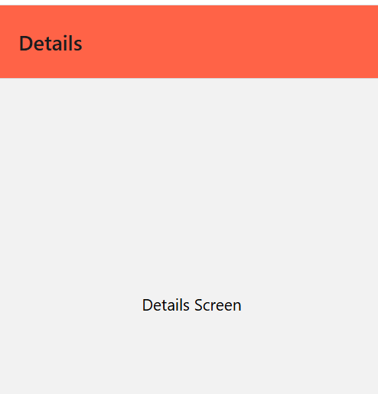
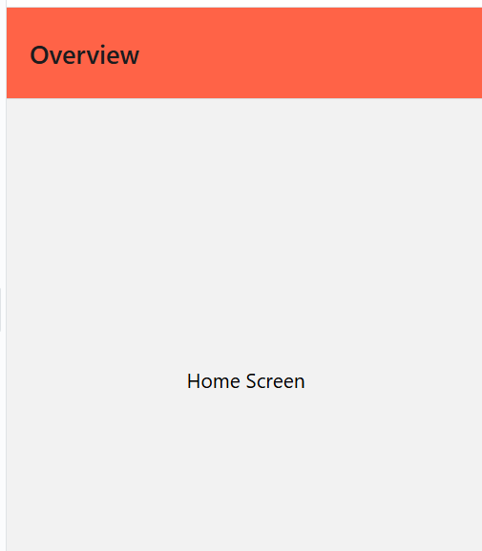

In this above code we are creating screens with a navigation setup, but not actually using navigation to move between them.
Moving between screens
In the previous section, we defined a stack navigator with two routes (Home and Details), but we didn't learn how to let a user navigate from Home to Details.
Using Link or Button components
The simplest way to navigate is using the Link component from @react-navigation/native or the Button component from @react-navigation/elements:
Code
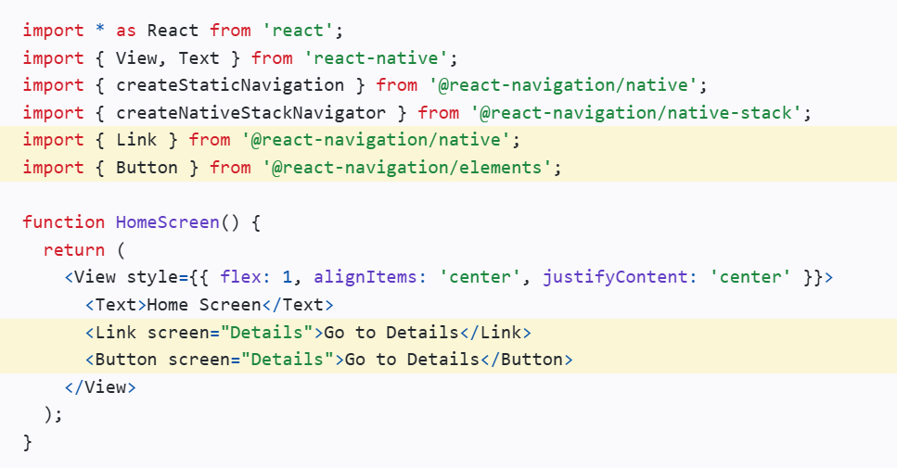
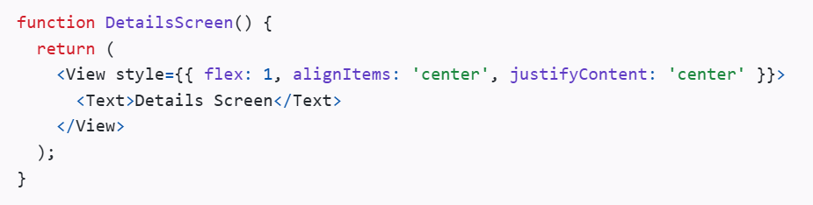
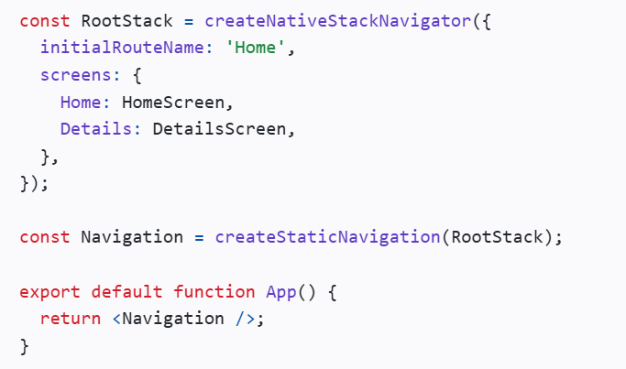
Output
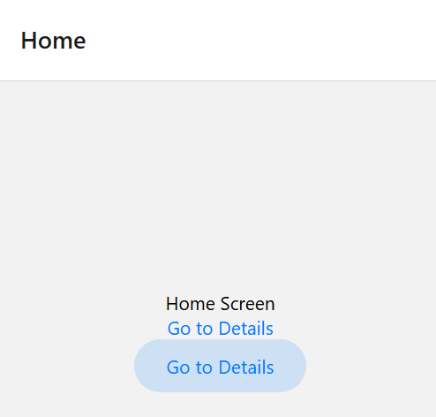
When we click on Go to Detail it will navigate us to Detail Sreen
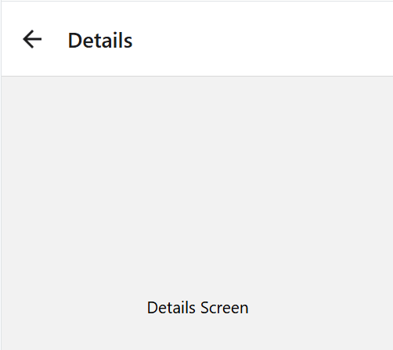
Using the navigation object
Another way to navigate is by using the navigation object. This method gives you more control over when and how navigation happens.
The navigation object is available in your screen components through the useNavigation hook:
Code
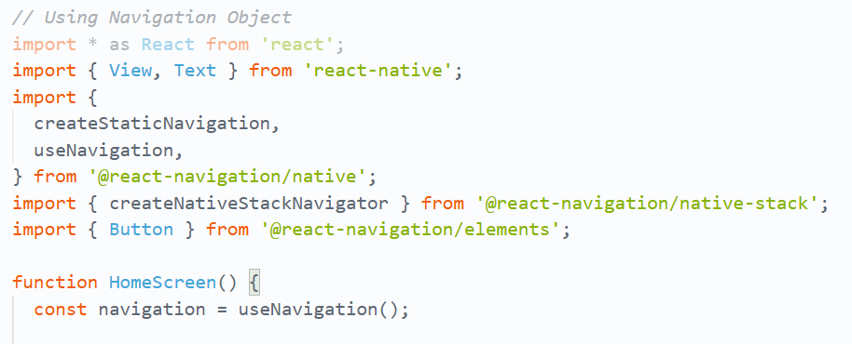

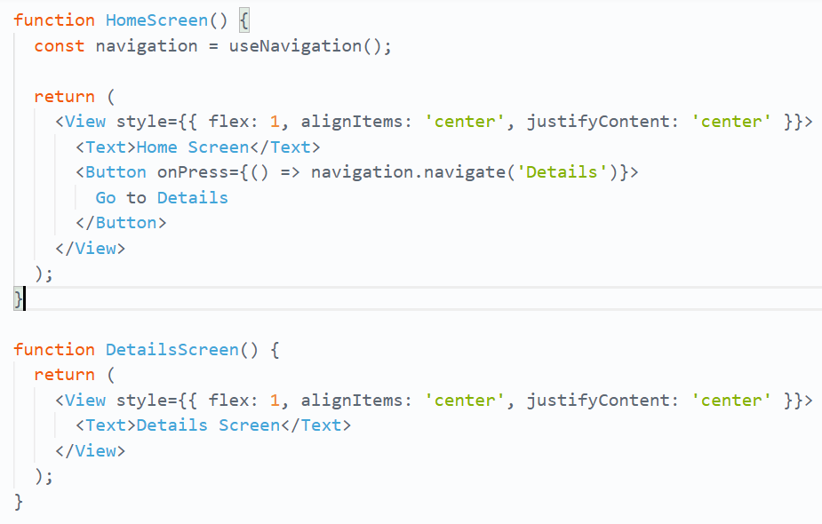
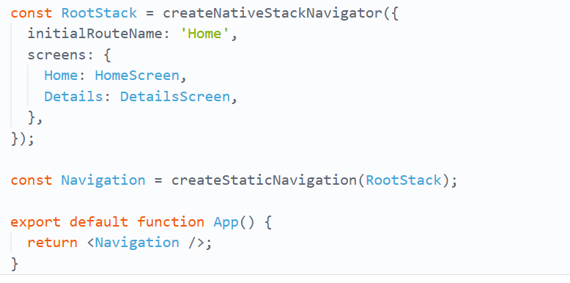
Output
- Output will be same as Link and Button

1. createNativeStackNavigator
createNativeStackNavigator is a function where you give a setup object that tells the app:
- which screens your app has
- and how those screens should behave
It returns an object with TWO React components:
- Navigator
- Screen
From React Navigation
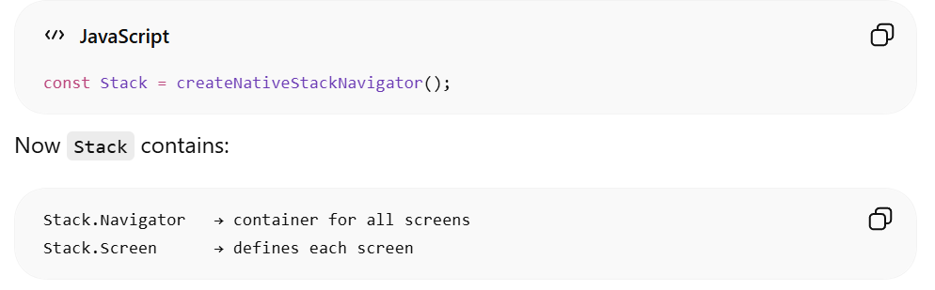
2. createStaticNavigation
It builds the full navigation system and gives you something you can directly render in App.js or App.tsx.
In a typical React Native app, the createStaticNavigation function should be only used once in your app at the root.

Navigate to a screen multiple time
What happens if we navigate to Details again while already on the Details screen?
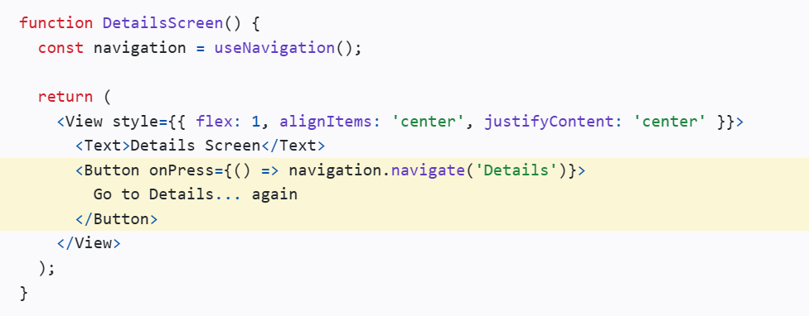
Tapping "Go to Details... again" does nothing because we're already on that route. The navigate function means "go to this screen" - if you're already there, it does nothing.
Let's say we actually want to add another Details screen.
This is common when you pass unique data to each route. To do this, use push instead of navigate. This adds another route regardless of the existing navigation history:
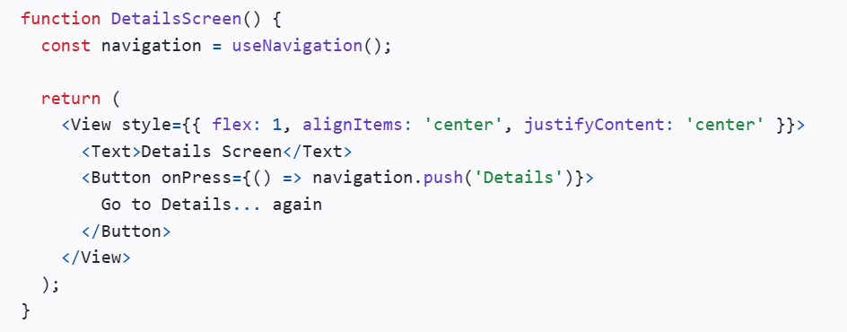
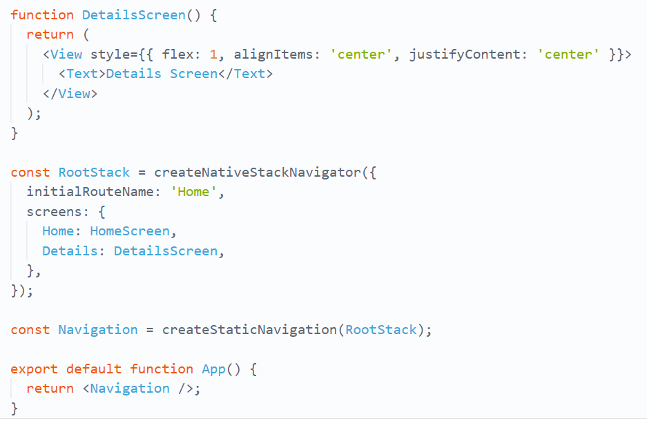

Now Suppose We have click 3 times on Goto Detail Screen Again
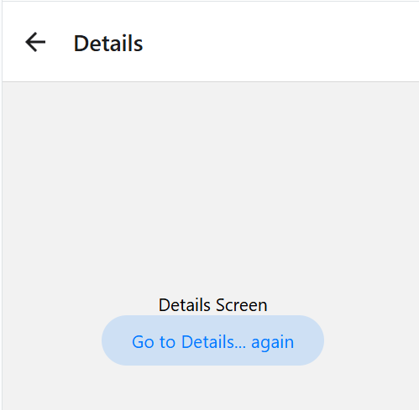
Now we will only navigate to Home Screen when we click back arrow exactly 3 times
Use of GoBack Function
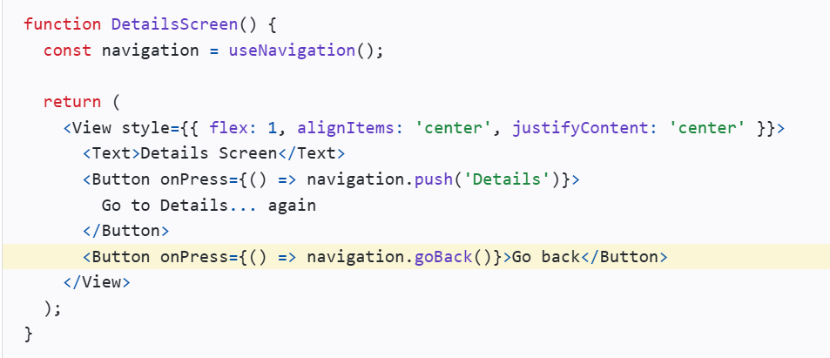
1st time when we click on GotoDetailScreen
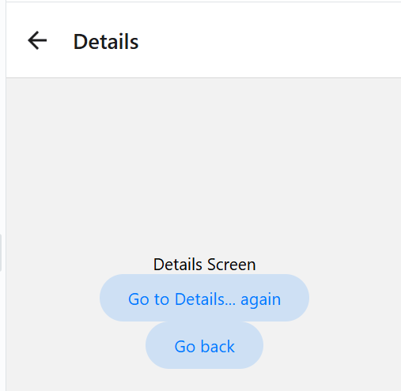
2nd Time when we click on Go to Details Again
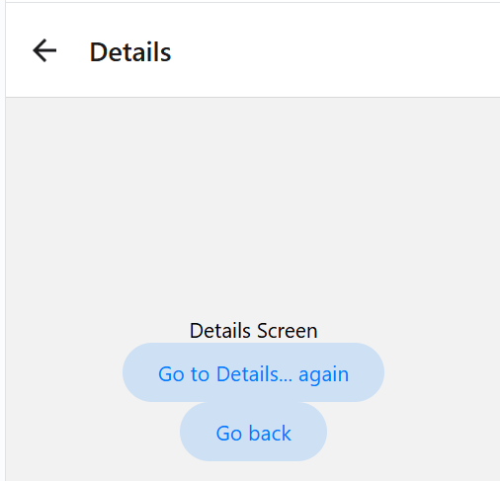
So we can clearly conclude that goBack() provide button for every click to DetailScreen.
Q: But here the Question is what if user want to go to Home screen at one click then GoBack() will not work so what will we do?
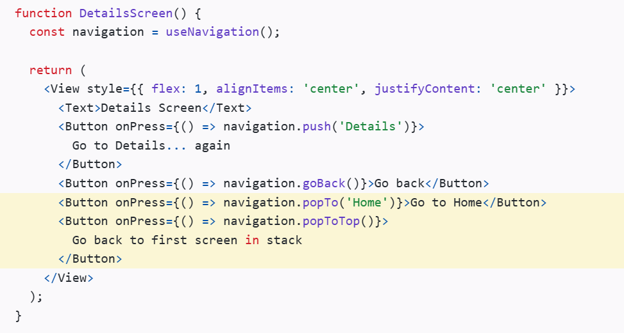
Now popToTop() lets users return to the Home screen in a single click, no matter how many screens they have navigated through on the Details screen.
Passing Parameters to Routes
When we move from one screen to another in React Navigation, we can also send some data with it.
This data is called parameters (params).
For example:
- Moving from a Home Screen to a Profile Screen
- Sending the user's name or ID to the Profile Screen
There are 2 simple steps:
1. Send Data While Navigating
We use navigation.navigate().
The first argument is the screen name.
The second argument is the data we want to send.
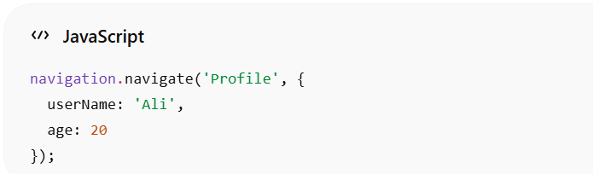
2. Receive Data in the Next Screen
The next screen gets the data using route.params.
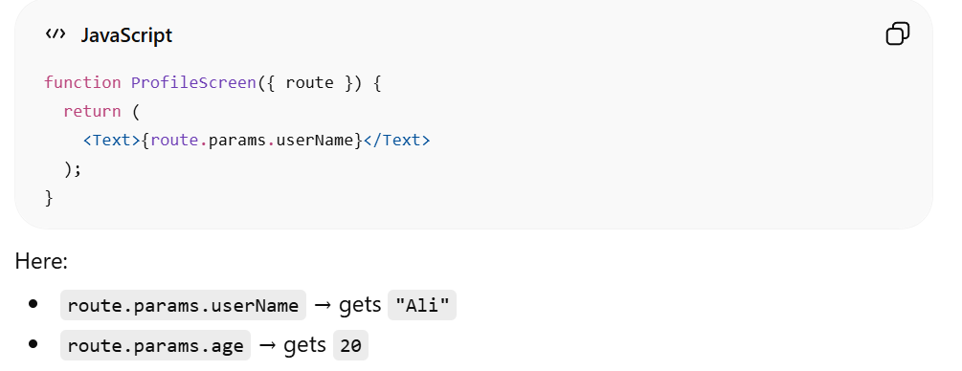
Complete Code
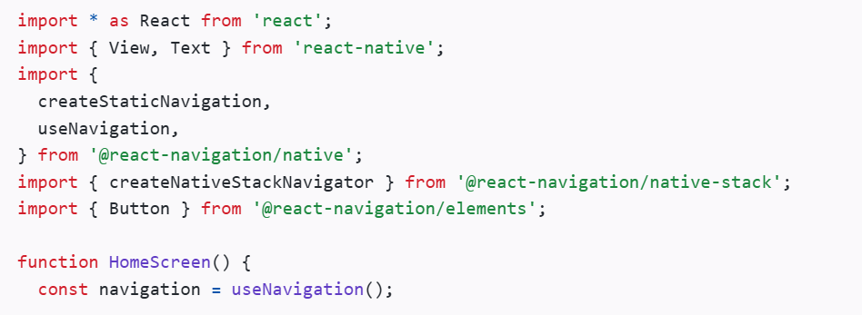
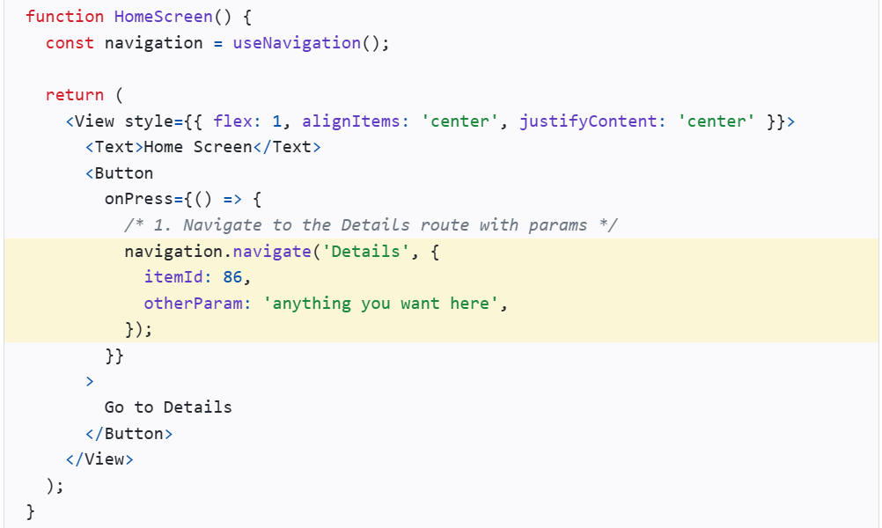
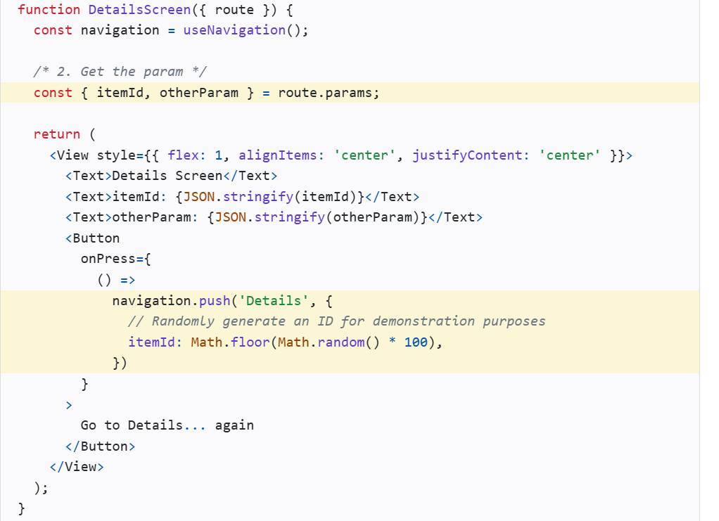
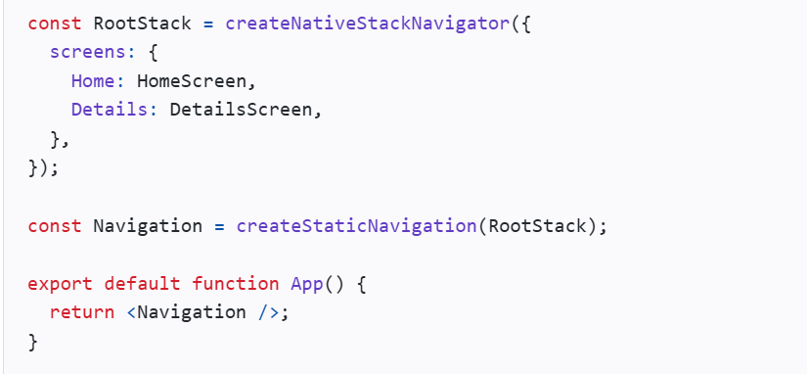

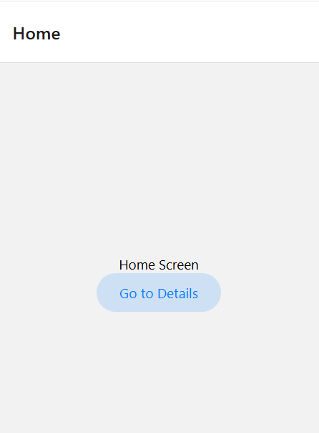
Output
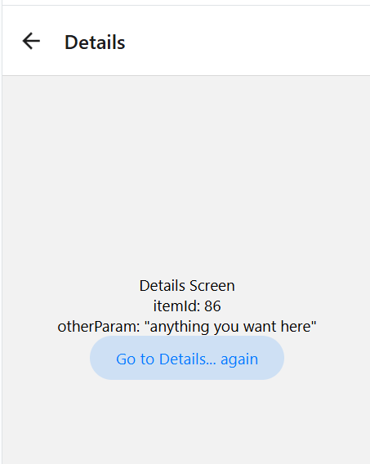

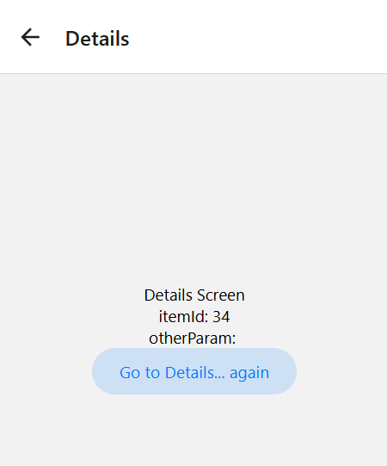

I
Initial Params
initialParams means:
- Default parameters for a screen.
- If no params are sent while navigating, React Navigation will automatically use these default values.
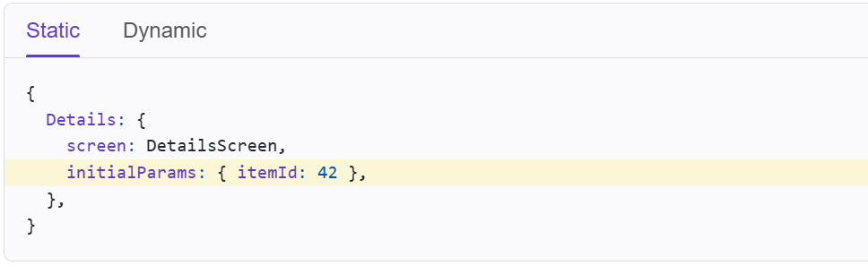
Updating params
Screens can update their params using navigation.setParams:
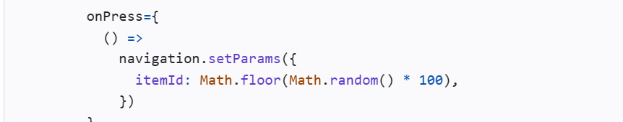
setParams merges new params with existing ones. To replace params entirely, use replaceParams.
Passing params to a previous screen
Params can be passed to a previous screen as well, for example, when you have a "Create post" button that opens a new screen and you want to pass the post data back.
Use popTo to go back to the previous screen and pass params to it:
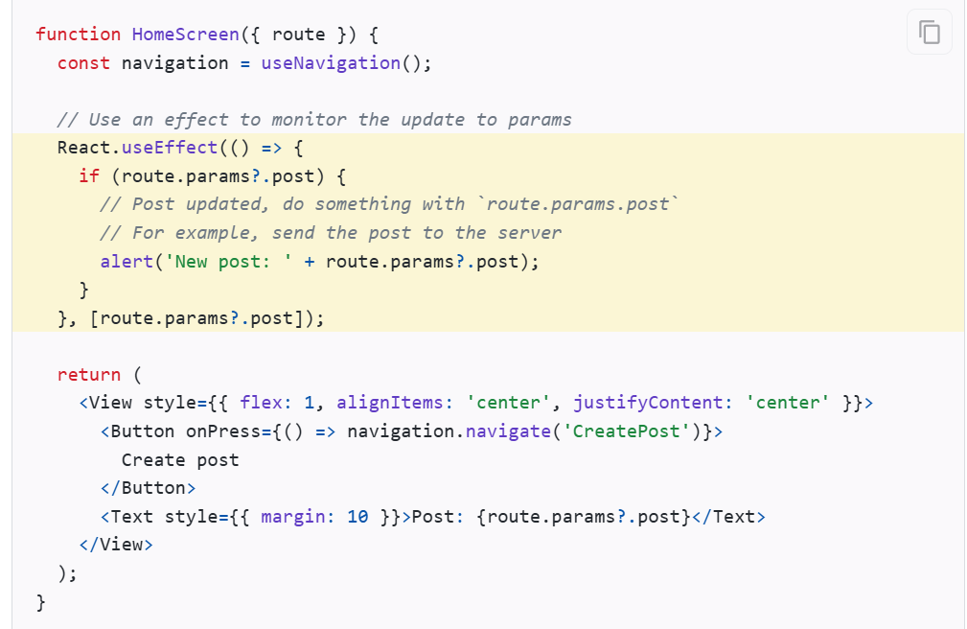
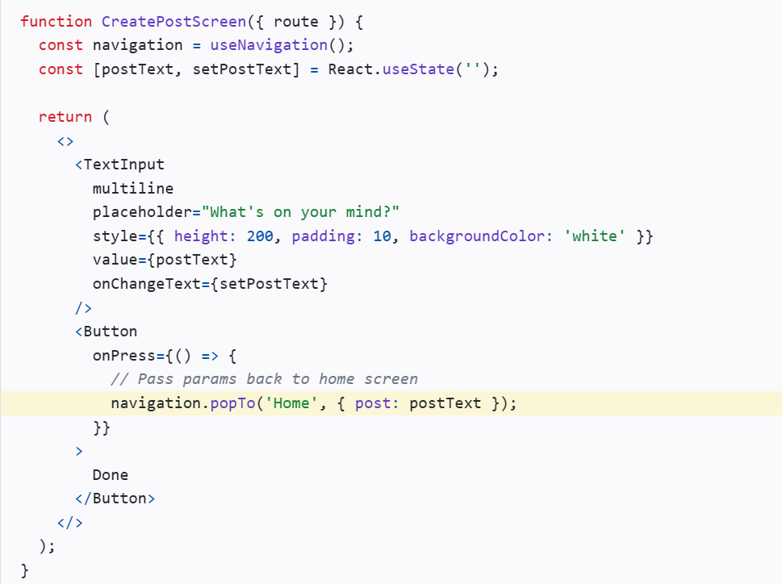
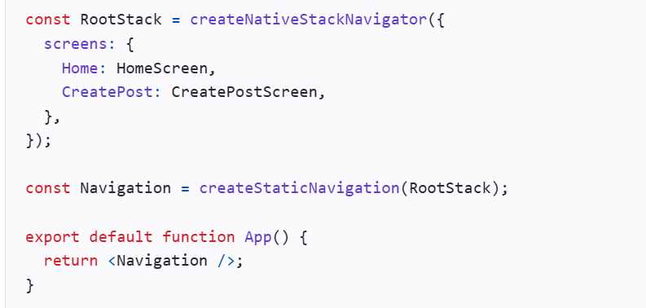
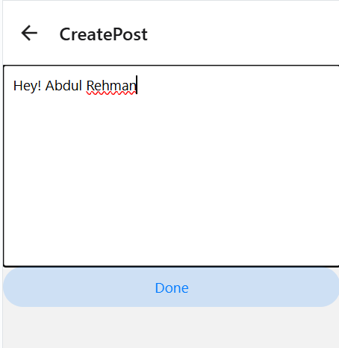
Output
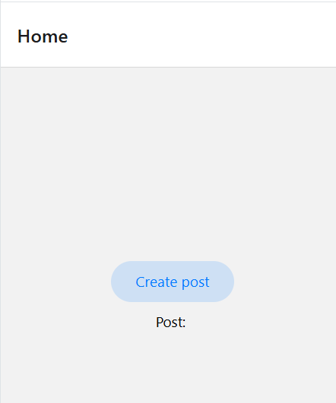

Now this data is passed to previous screen which is home
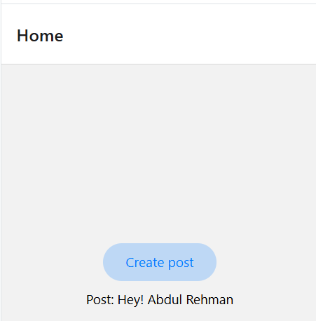

What should be in params
Params should contain the minimal information required to show a screen:
- Data to identify what to display (e.g. user id, item id)
- Screen-specific state (e.g. sort order, filters, page numbers)
Think of params like URL query parameters - they should contain identifiers and state, not actual data objects. The actual data should come from a global store or cache.
For example, say you have a Profile screen. You might be tempted to pass the user object in params:
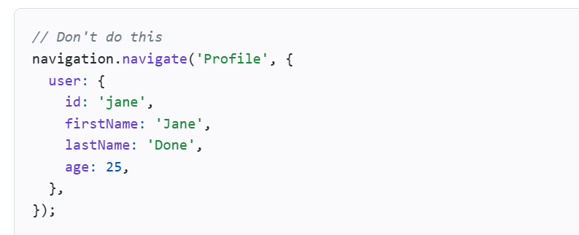
This is an anti-pattern because:
- Data is duplicated, leading to stale data bugs
- Each screen navigating here needs to know how to fetch the user
- URLs/deep links would contain the full object, causing issues
Instead, pass only the ID:
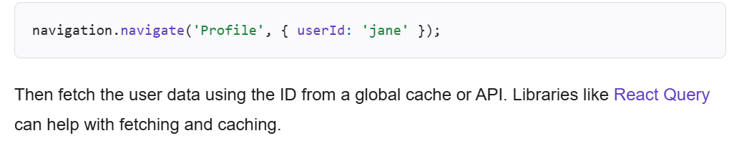
Configuring the header bar
We've seen how to configure the header title already, but let's go over that again before moving on to some other options.
Setting the header title
Each screen has an options property (an object or function returning an object) for configuring the navigator. For the header title, we can use the title option:
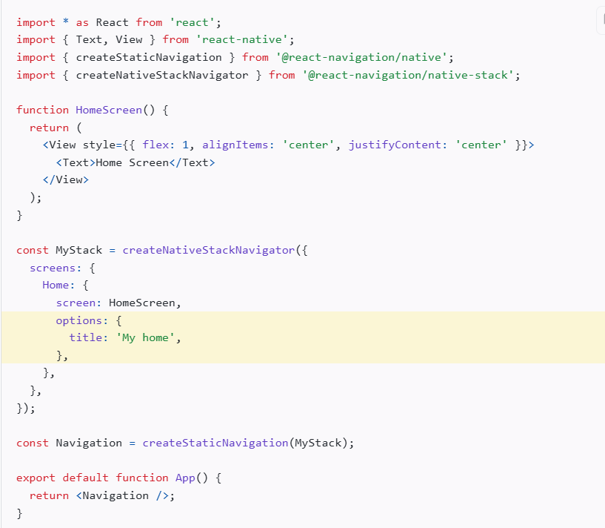
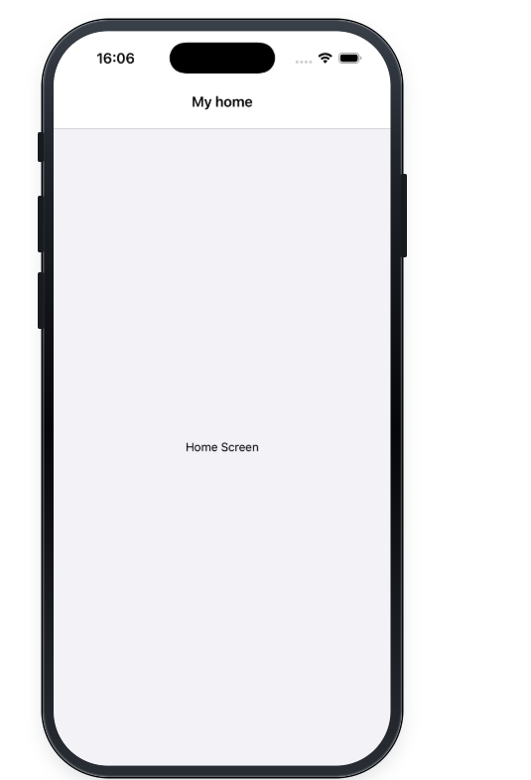
Using params in the title
To use params in the title, make options a function that returns a configuration object. React Navigation calls this function with { navigation, route } - so you can use route.params to access the params:
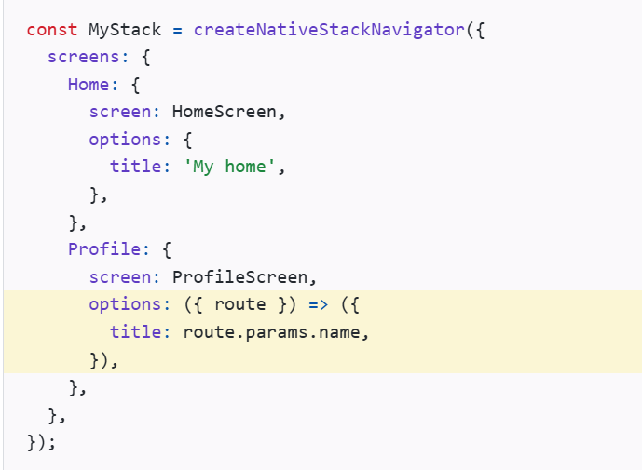
The argument that is passed in to the options function is an object with the following properties:
- navigation - The navigation object for the screen.
- route - The route object for the screen
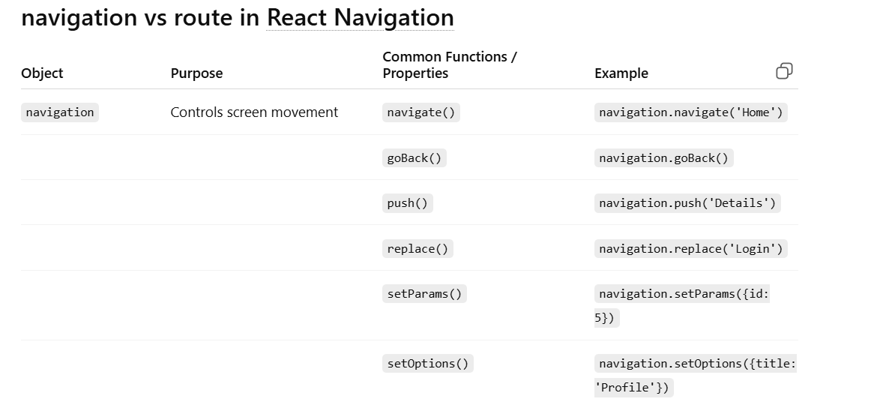
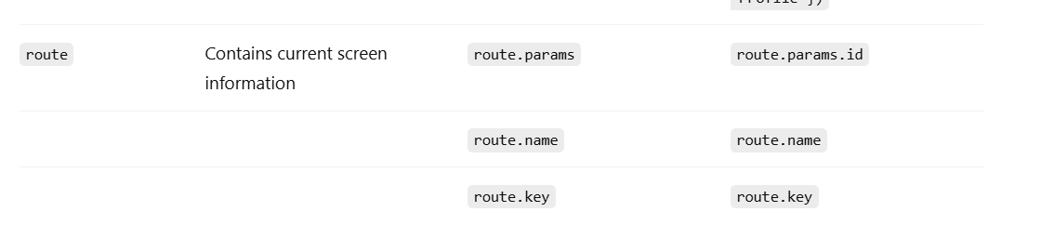
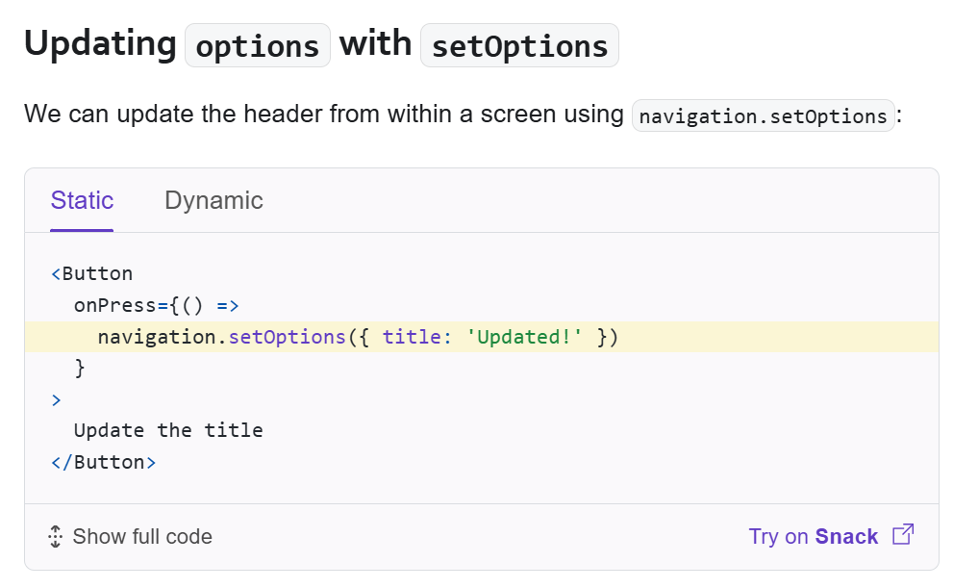
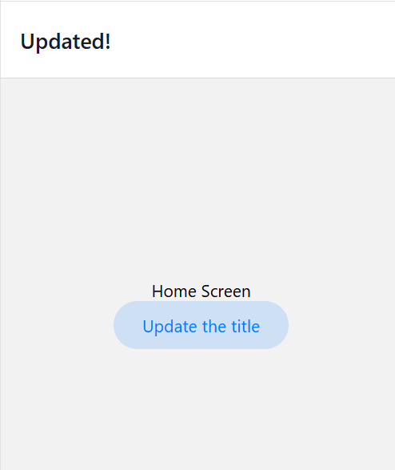
When click on button Update title screen name change to Update
Header Buttons
Adding a button to the header
The most common way to interact with a header is by tapping a button to the left or right of the title. Let's add a button to the right side of the header:

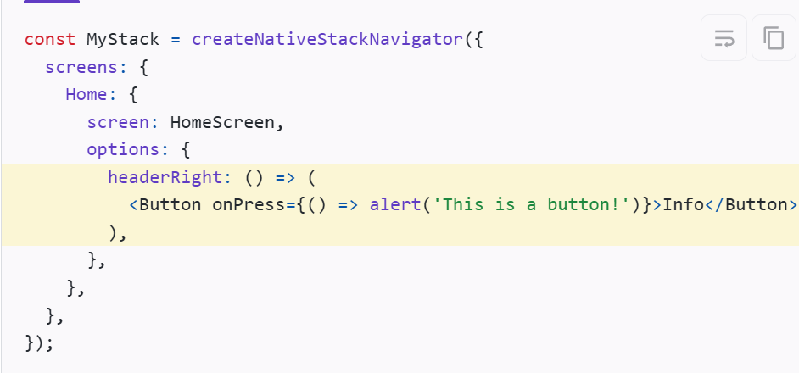
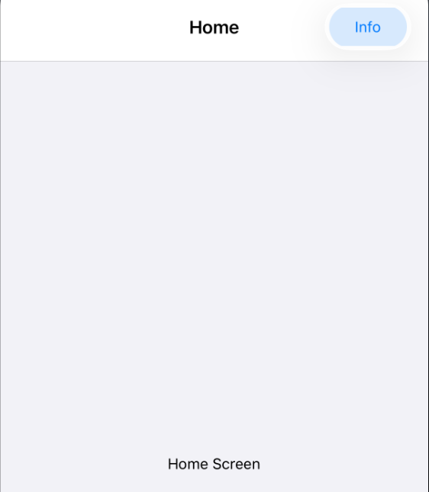
Header interaction with its screen component
To make header buttons interact with screen state, we can use navigation.setOptions inside the screen component
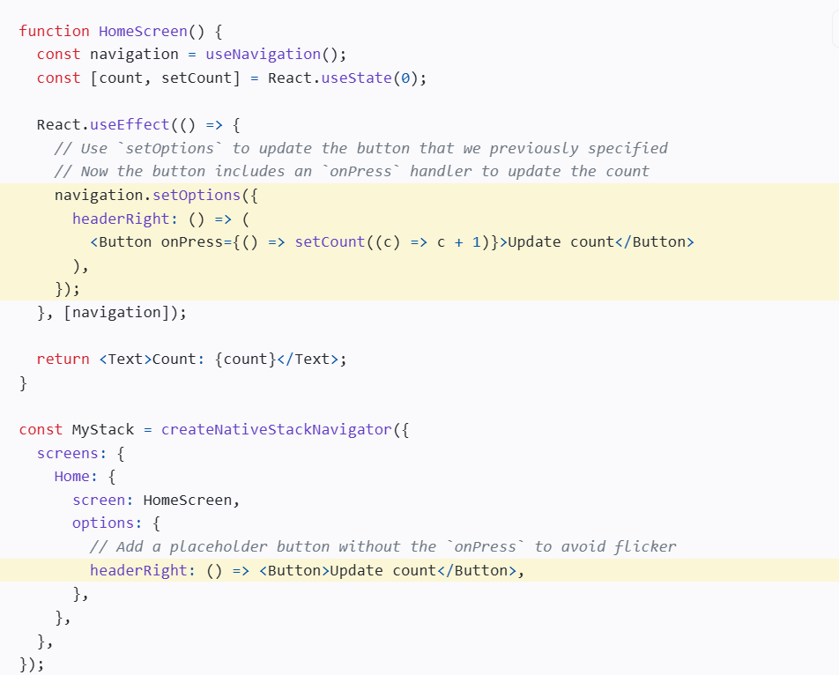
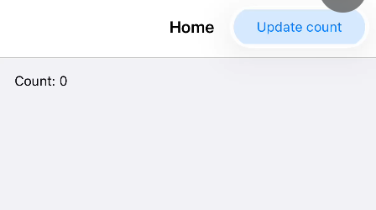
2. NavigationContainer
In React Navigation, NavigationContainer is the root wrapper of your navigation system.
Simple meaning
NavigationContainer = “Activation box for navigation”
It:
- Turns on navigation system
- Keeps track of screen history
- Stores navigation state (which screen is active)
- Connects your app with navigation logic
Imp: Anything inside NavigationContainer becomes part of navigation system
3. initialRouteName
In React Navigation, initialRouteName decides which screen opens first when our app starts.
4. Options
Options are used to customize a screen’s header, title, and appearance in navigation.
Without options, the screen title is automatically the same as the screen name.
5. useNavigation
useNavigation is a hook that gives navigation control to any component so you can move between screens even outside screen components.
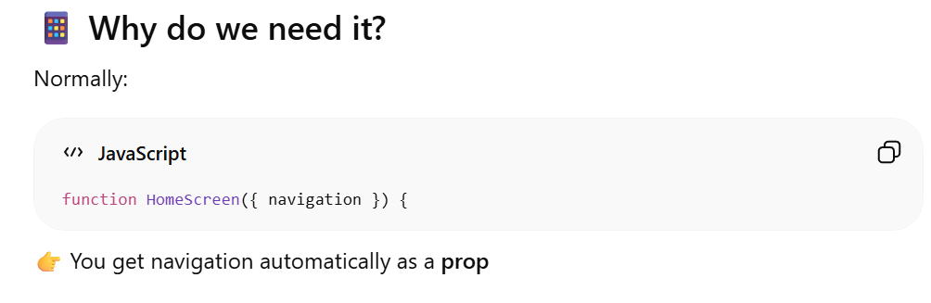
But sometimes:
- You are NOT in a screen
- Or you are in a child component
Then you cannot get navigation prop
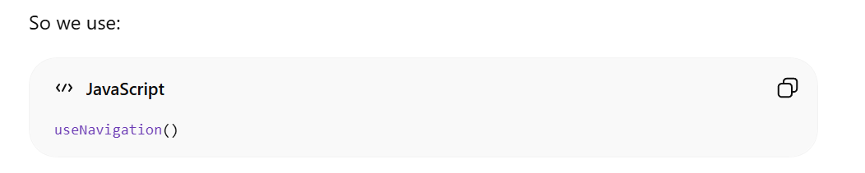
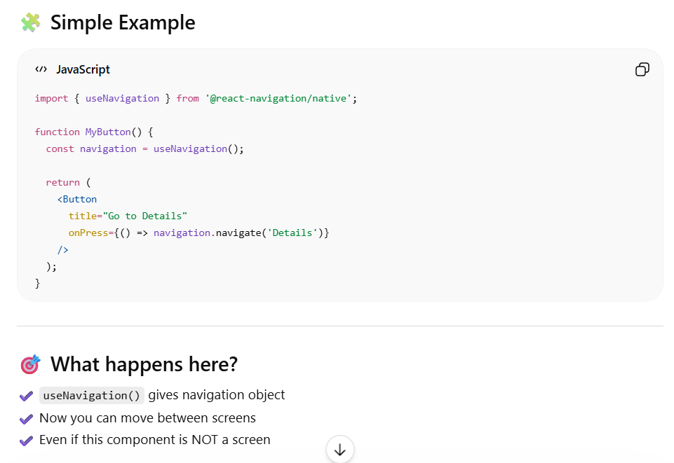
Imp: Navigation props are only given to screens because only screens are part of the navigation stack, not child components.
6. Stack Behavior (Push vs No Duplicate / Screen Reuse Concept)
navigation.navigate() behavior in Stack Navigator
If screen is NOT in stack:
- It is added (pushed) into the stack
If screen ALREADY exists in stack:
- React Navigation usually does NOT add a duplicate
- Instead, it jumps back to the existing screen

7. popToTop()
In React Navigation, popToTop() is a navigation function used in Stack Navigator to go directly to the first screen (Home) and remove all other screens above it
